Dancing to Live Music
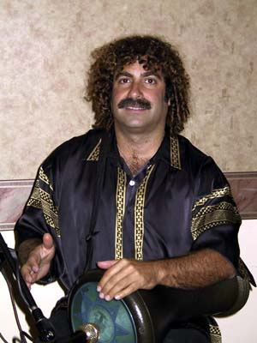
Workshop
with
Renée Arnold
& Frank Lazzaro

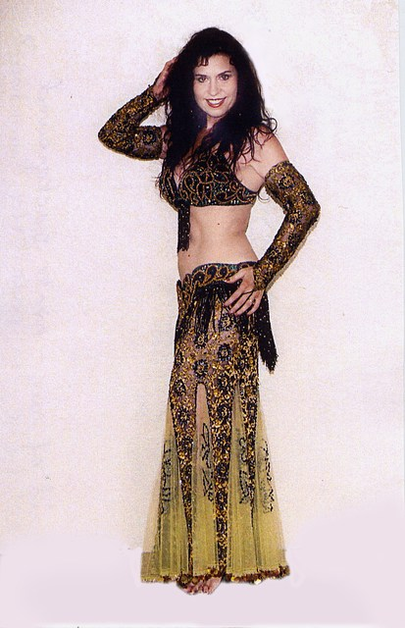

Monday, October 23, 2006

*7:00 p.m. - 9:00 p.m.
$45.00

Kapi’olani Community College
Maile Bldg.
Kilauea Ave. between 15th & 16th

If you have been dancing primarily to CDs, here is an opportunity to learn from an internationally experienced dancer how to perform to live music, how to communicate with musicians and how to interpret and anticipate the music. Learn from a visiting San Diego based drummer/instructor what musicians expect from dancers.

*Pre-registration recommended. Contact Sonia Fabrigas at aiwanaartists@sbcglobal.net
or call (808) 524-8416. Please arrive before 7:00 to register at the door.
Visit www.middleearthband.net and www.reneearnold.com

